**Finance commission**

**INTRODUCTION TO FINANCE COMMISSION**

- Fiscal Federalism refers to the separation of revenue and expenditure obligations among the several levels of government.

- While the 7th schedule delegated numerous obligations to the states, their taxing authority is limited in comparison to the Union's. As a result, the Finance Commission is critical in moving revenue from the union to the state.

**Finance commission:**

The Indian constitution establishes a financial commission as a quasi-judicial entity in Article 280. It is established by the President of India every fifth year or sooner if he deems it necessary.

A chairman and four additional members are selected by the president to the financial commission. They serve for the length of time indicated by the president in his order. They have a chance to be re-appointed.

On November 22, 1951, the first financial commission was established under the chairmanship of K.C. Niyogi. The committee's recommendations were submitted in 1953.

On the 2nd of January 2013, the president issued an order to form the 14th Finance Commission, whose term will run from 1st April 2015 to 31st March 2020. Y.V. Reddy is the commission's chairman. The 13th Finance Commission recommended that the state's part of the union tax be increased from 32 percent to 42 percent.

The finance commission proposes a principle for the grant-in-aid of revenues from the consolidated fund of India to states. The president receives the commission's report.

The finance commission's job is to recommend how the net revenues of taxes should be distributed between the union and the states; the inter-state council is in charge of state coordination and cooperation; and the planning commission's job is to allocate resources between the centre and the states. "NITI AAYOG" has taken over the planning commission (National Institution for Transforming India).

The constitution's seventh schedule governs the division of powers between the union and the states. This has three sub-lists:

1. Union list
2. State list
3. Concurrent list

According to Article 280(3) of the constitution, the main function of the finance commission is-

1. 1. To make recommendations for the division of tax revenue between the union and the states.
2. 2. To establish the criteria that shall govern the grants in aid of revenues to states from the India Consolidated Fund.
3. 3. On the basis of the finance commission's suggestion, suggest the appropriate measures to raise the consolidated fund of the states for the development of Panchayats in the state.
4. Any other subject that the president refers to the panel in the interest of prudent financial management. The parliament's role is to authorise withdrawals from India's consolidated fund. The finance ministry's job is to make sure that the federal government and state governments are collecting taxes in accordance with the budget's stipulations.

The finance commission of India makes recommendations under article 280(3) of the constitution in the following cases:

• Distribution of federal tax receipts between the union and the states;

• Aid in the revenue of the states under article 275; and

• Any other topic that the president recommends to the commission.

On the proposal of the finance commission, income tax is levied and split between the union and the states under article 270, while central excise tax is shared under article 272. The financial commission also calculates state grant-in-aids under article 275, but the trade tax is imposed and collected by the states, whose distribution is not the finance commission's responsibility.

According to Article 243(1) of the constitution, the governor of a state shall establish a finance commission to review the financial position of the panchayats and make recommendations to the governor as soon as possible, but no later than one year after the constitution (73rd amendment act) 1992 takes effect, and then every fifth year. As a result, the state finance commission is a legal entity. The finance commission is required by Article 280(3) (bb) of the constitution to give recommendations to the panchayats and municipalities "on the basis of the recommendations made by the state finance commission."

The provisions of Articles 268 to 279 relating to the division of taxes between the union and the states can be suspended by parliament's order during a national emergency, subject to specified modifications as necessary by the order, as stipulated in Article 354(1) of the Indian constitution.

The finance commission is made up of four members, including the chairperson, who is selected by the president of India, as per article 208(1) of the constitution.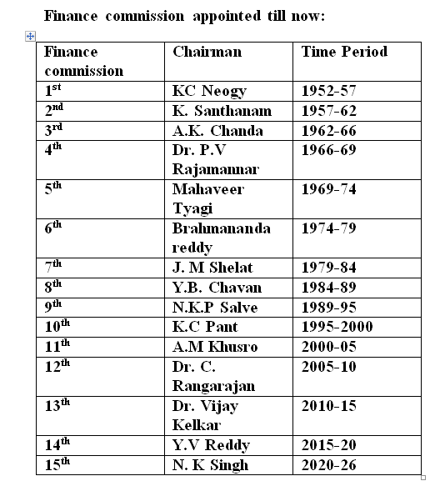

Q1: Which entity look after the distribution of taxes between center and states?

1. Niti Aayog
2. Finance Commission
3. Reserve bank of India
4. PMO office

**2**

Q2: Which of the following is the basis for distributing the net revenues of taxes between the centre and the states, as recommended by the President?

1. Ministry of Finance

2. RBI

3. The Finance Commission

4. Parliament

3

Q3. The Indian constitution allows the President to appoint a finance commission after a period of from the constitution's inception?

1. 2 years
2. 3 years
3. 5 years
4. 10 years

**1**

Q4. Which of the following periods were covered by the first Finance Commission's recommendations?

1. 1951-56

2. 1952-57

3. 1953-58

4. 1954-59

**2**

Q5. The President of India appoints the Finance Commission under…..?

1. Article 262
2. Article 315
3. Article 280
4. Article 261

3

Q6: What is the purpose of the Finance Commission?

1. Budget recommendations

2. State-to-state financial cooperation

3. Financial assistance to the most vulnerable.

4. Recommendations on tax income sharing between the Union and the States, as well as among the States themselves

4

Q7. What credentials does the Finance Commission lack?

1. Qualified to serve as a High Court Judge

2. Has extensive financial knowledge

3. In-depth understanding of economics

4. High Court counsel with three years of experience

4.

Q8. In addition to the 1971 statistics, the 14th Finance Commission used _____ demographic data.

1. The 1981 Census

2. The 1991 Census

3. Census 2001

4. Census 2011

4

**Q9: When was the first Finance Commission established?**

1. 1951
2. 1955
3. 1960
4. 1961

1

**Q10. Who was Finance Commission's first chairman?**

1. Y. V. Reddy

2. J. P. Kripalani

3. K. C. Neogy

4. N.K Singh

3

**Q11: Take a look at the following statements.**

**i. Taxation distribution between the federal government and the states**

**ii. The grant-in-aid from the Consolidated Fund of India for state revenues**

**Choose the correct code from the list below.**

1. i Only

2. ii Only

3. i & ii

4. Non of the above

3

Q12. Who is in charge of appointing the Finance Commission?

1. Prime Minister

2. President

3. Finance Minister

4. Home minister

b

**Q13. Who will be the chairman of the 15th Finance Commission?**

a. Raghuram Rajan

b. Shanmukhan Chetty

c. Y.V. Reddy

d. N. K. Singh

d

**Q14. What is the title of the 15th Finance Commission report?**

a. Finance Commission in Covid pandemic

b. Finance Commission in Nature Calamities

c. Finance Commission in COVID Times

d. Finance Commission in Corona pandemic

c

Q15. Would the proposals of the 15th Finance Commission be valid for the period from

a. 2020 to 2026

b. 2020 to 2025

c. 2021 to 2025

d. 2021 to 2026

b